Decision Tree Intuition

CART: Classification and Regression Trees

Consider the following data distribution

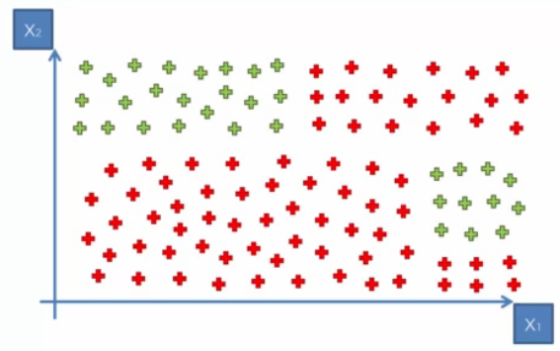

This data will then be split into different parts as follows

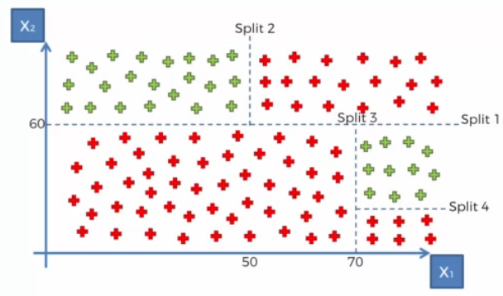

The splits are done in such a way that maximum data points from each category are grouped together